1. How to run Application in Unix.
2. Export project to runnable jar(I have uploaded the executable jar as well)
3. Simple run java -jar <jar-file>
4. Main Method

Main method is define in ItemMain class.

Points on which application is created

* Follow each product’s link to get the calories per 100g (in kcal) and its long description to include in the JSON.

Sample data is created in ItemDao class

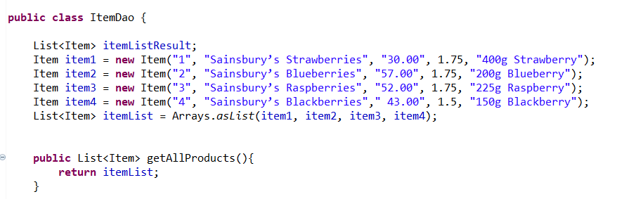

* Each element in the JSON results array should contain title, unit_price, kcal_per_100g and description keys corresponding to items in the HTML.
* 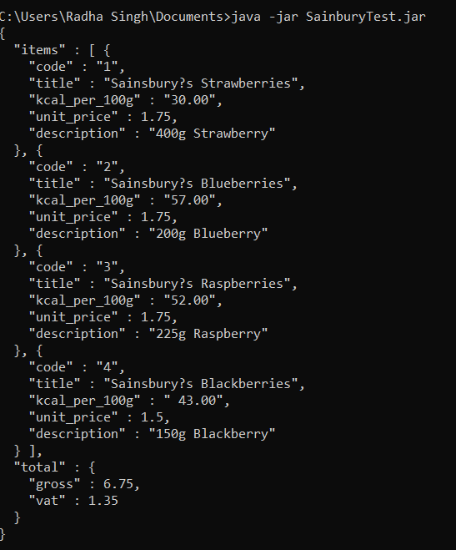
* Do not include cross sell items, such as the Sainsbury’s Klip Lock Storage Set.
* Omit the kcal_per_100g field, if calories are unavailable.

It is handled on the property level

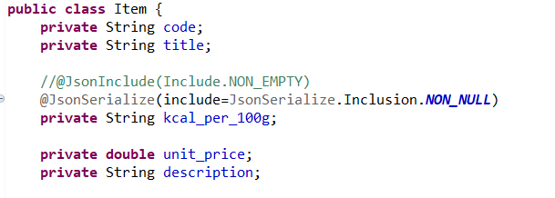

* If the description is spread over multiple lines, scrape only the first line.

Code written in service class

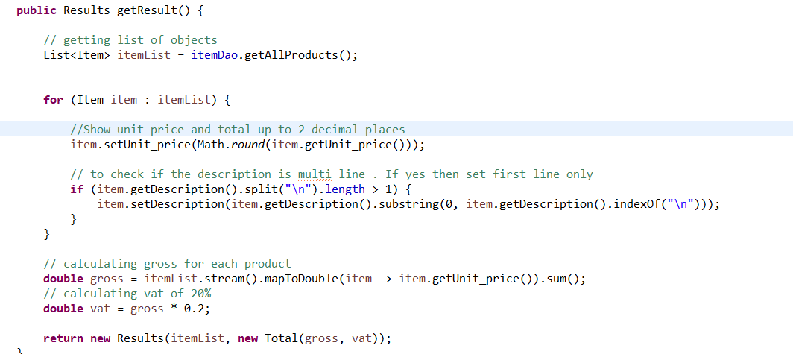

* Show unit price and total up to 2 decimal places, representing pounds and whole pence.(shown in above screen)
* Additionally, include a total field. This contains two sub-fields: gross and vat. gross will be the total of all the items on the page. the vat will be the VAT on the gross amount.
  + For example with a gross of £5.00, the VAT woud be £0.83.
  + In this test, every item has 20% VAT.